19th Annual Basics of Substance Use Disorders

Friday, December 6th, 2019 8:00am-4:00pm
Paris Fire Department, South Paris

Target Audience: Educators, Parents, Employers, Nurses, Doctors, Substance Abuse Counselors, Law Enforcement, Clergy, Social Service Workers, People in Recovery, Family Members and Friends Affected by Substance Use Disorder, & Others Wanting to Know More About Substance Use Disorders

8:00 - 8:30 Registration, Refreshments, & Visit w/ Exhibitors
8:30 – 8:45 Andy Robinson; Open Remarks
8:45 – 10:15 Gordon Smith & Mike Sauschuck - Current state of the opioid epidemic from the State’s Opioid Response
10:15 – 10:45 National Alliance on Mental Illness – Co-occurance of mental health and substance use
10:45 – 11:00 BREAK
11:00 – 11:30 Scott Gagnon; Marijuana – Understanding the Impact to Communities
11:30 – 12:00 Bill Lowenstein; Trauma, Addiction, & Recovery
12:00 – 1:00 LUNCH & NETWORKING
1:00 – 1:45 Journey House Representative – Stigmatizing Language
1:45 – 2:30 Matt B. & Andy – Police and Courtroom Perspective
2:30 – 2:45 BREAK
2:45 – 3:15 Panel Discussion: AA/YPR/SMART/Recovery Coach/Affected Family Member
3:15 – 3:45 Jenni Joan – Mindfulness & Recovery
3:45 – 4:00 Andy R.; Closing Remarks

NARCAN TRAINING WILL BE AVAIABLE AFTER THE CONFERECE
Please let Daphne know you’re interested when registering.

Exhibitors include state & local service providers and recovery programs.

$15 Fee Includes Snacks and Lunch Full Scholarships are Available

7 Contact Hours are Available

Scholarships are funded by the Marj and Fred Stockwell Charitable Remainder
Annuity Trust, Gateway Endowment, & Local Area Service and Prevention Providers

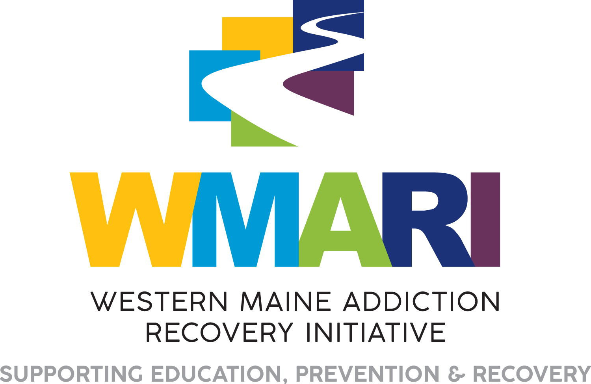

To Register
Preferred: E-mail registration information to Daphne@commongroundcounseling.org.
Call in registrations are accepted for those without email: 739-2644.
Registrations/payment can be mailed to: Common Ground Counseling,
235 Main St., Norway, Me, 04268

Make Checks Payable to: Stephens Memorial Hospital
Credit Cards Accepted
*Full Scholarships Available

Name: __________________________________________________ Phone:__________________
Organization:_______________________________ Email:_________________________
Address:_________________________________________________
FEE $15.00 Enclosed: $___________

